LIA Assurex S.A.L. - CTL FORWARDING S.A.R.L - New AI Claim

ULA reference: ULA-2026-0010 - 1v1
Applicant's Name: LIA Assurex S.A.L.
Assured's Name: CTL FORWARDING S.A.R.L
Policy No.: ZK-MAA-0104947
31 August 2026

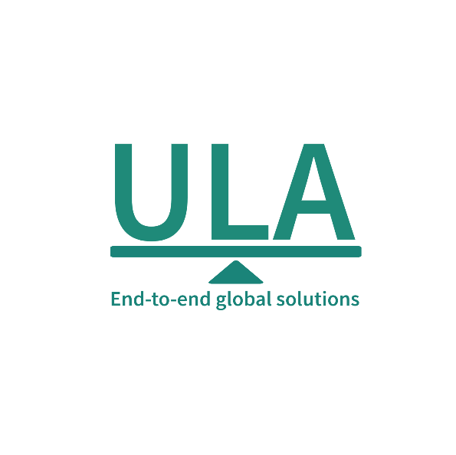
It’s about time you receive the quality of service and expertise your firm deserves.
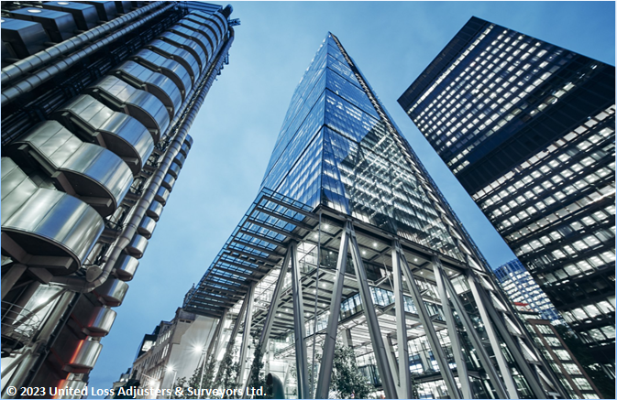

Document Control Page
Written by: | Reviewed by: | Approved by:
Tony Lahoud | To be assigned | To be assigned
Designation: | Designation: | Designation:
Claims Handler | Claims Director / Technical Reviewer | Director / Chartered Adjuster
Signature (Approver)
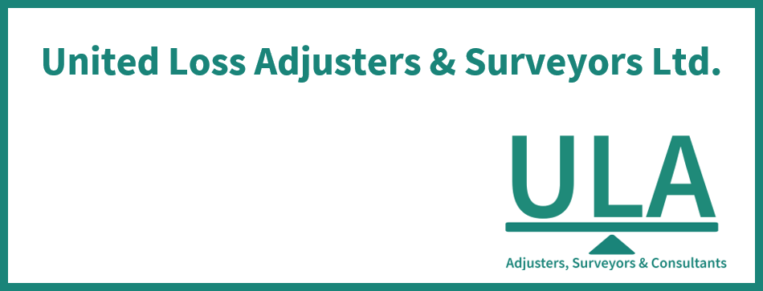
This survey and its issued report were completed without prejudice to all rights of parties concerned.
Date of approval
Pending professional approval

Version History | Date of issue | Reason for Revision
1 | 31 August 2026 | Locally generated controlled draft; professional review required
The contents of this report are for the confidential information of the client
This survey and its issued report were completed without prejudice to all rights of parties concerned and its concluded adjustment is in accordance with the terms and conditions of the relevant insurance policy.
Report Summary
At the request of LIA Assurex S.A.L. (the Applicant), ULA was requested to investigate a Marine Cargo (Non-Reefer) claim for CTL FORWARDING S.A.R.L (the Assured), establish the circumstances and extent of loss, and adjust the claim presented under the policy. The insured interest is Marble tiles and slabs.
In brief, Table 1 records CTL FORWARDING S.A.R.L as the Assured, Marble tiles and slabs as the insured interest, movement from Beirut, Lebanon to France, Policy No. ZK-MAA-0104947.
Assured's / Shipper's Name | CHOUCAIR GROUP SAL
Consignee's Name | DIMA DEBS ARCHITECTURE
Insurance Policy | No. ZK-MAA-0104947  Insured Value / Limit: EUR 87,892.51  Basis of Valuation: Invoice value / ICC(A)  Deductible / Excess: EUR 10,750.00

In our opinion,
- The above adjusted claim amount in USD cannot be stated as fair & reasonable because a fully supported and reconciled USD adjusted amount is not established from the reviewed evidence.
- The proximate cause of loss is not established from the available evidence.
- Cover advice: ICC(A) provides all-risks cover for physical loss or damage subject to exclusions and warranties. Key issues are: (1) Packing warranty – 'Warranted Professionally & Suitably packed': photographic evidence of crate frame collapse inside the container (photo p.
- Liable-party position: A carrier and/or transport contract is identified. Liability, defences, time bars, notice compliance, and recoverability require separate professional determination from the carriage documents and facts.
- We confirm having sighted the originals of all documents customarily submitted in support of a claim of this nature and remain at Insurers disposal for further instructions.
Report and adjustment note
At the request of LIA Assurex S.A.L. (the Applicant), ULA was requested to investigate a Marine Cargo (Non-Reefer) claim for CTL FORWARDING S.A.R.L (the Assured), establish the circumstances and extent of loss, and adjust the claim presented under the policy. The insured interest is Marble tiles and slabs. This report and adjustment note sets out our findings, causal assessment and adjustment position; supporting documents are retained and transmitted separately.
Table 1 - Summary and salient details
Applicant's Name | LIA Assurex S.A.L.
Assured's Name | CTL FORWARDING S.A.R.L
Insurance Policy | No. ZK-MAA-0104947  Insured Value / Limit: EUR 87,892.51  Transit Scope: Sea, Beirut to France  Basis of Valuation: Invoice value / ICC(A)  Clauses / Basis of Cover: ICC(A) plus named endorsements  Extensions / Inclusions: Preliminary survey warranty at destination customs warehouse  Warranties: Warranted preliminary survey, to be held in customs warehouse in case of apparent or suspicious signs of damages.  Conditions: As stated  Exclusions: Excluding any Direct or lndirect Loss by lnfectious Disease outbreak,  Deductible / Excess: EUR 10,750.00
Incoterm / Terms of sale | Not established from the reviewed evidence
Transport Document | Bill of Lading: Not established from the reviewed evidence
Shipper's Name | CHOUCAIR GROUP SAL
Consignee's Name | DIMA DEBS ARCHITECTURE
Cargo / Commodities | BSIU3470622; Marble tiles and slabs
Origin / Destination | Beirut, Lebanon / France
Carrying Vessel / Carrier | CMA CGM NANSHA / 0NVMHN1MA; CMA CGM Société Anonyme au Capital de 234 988 330 Euros
Cargo Arrival / Delivery Date | Discharged 2026-07-18; Arrived 2026-07-18; Empty container returned 2026-07-24

INTEREST INSURED & RELEVANT CONDITIONS OF INSURANCE POLICY
Marble tiles and slabs was documented for transit from Beirut, Lebanon to France under Policy No. ZK-MAA-0104947.

SHIPMENT ROUTING
Beirut → Le Havre (CMA CGM NANSHA 0NVMHN1MA) → Paris inland by Sterna

SURVEYOR NOTES
- Material chronology. 01/06/2026: Commercial invoice issued. 16-JUN-2026: Cargo shipped on board. 2026-06-17: Cargo departed. 2026-06-09: Policy inception. 2026-06-10: Policy issued.
- Shipment and transit. Container BSIU3470622 (seal M1813527) was stuffed in Beirut, gated out empty 03-Jun, ready-to-load 05-Jun, departed 17-Jun-2026 on CMA CGM NANSHA. Vessel arrived Le Havre 18-Jul, container discharged same day, gated out to consignee 22-Jul, delivered by Sterna to 32 Rue Jean Goujon Paris 23-Jul, empty returned Rouen 24-Jul. Photographic evidence confirms physical breakage and chipping of marble slabs and strips across multiple marble types: corner chips on travertino romano slabs (photos pp. 2,8,16), fractured arabescato vagli and travertino tortora strips (photos pp.
Description | Boxes / Quantity | Packing
Not established from the reviewed evidence | Not established from the reviewed evidence | Not established from the reviewed evidence

CAUSE OF LOSS
The proximate cause of loss is not established from the available evidence.
The material physical and survey circumstances are as follows: Container BSIU3470622 (seal M1813527) was stuffed in Beirut, gated out empty 03-Jun, ready-to-load 05-Jun, departed 17-Jun-2026 on CMA CGM NANSHA. Vessel arrived Le Havre 18-Jul, container discharged same day, gated out to consignee 22-Jul, delivered by Sterna to 32 Rue Jean Goujon Paris 23-Jul, empty returned Rouen 24-Jul. Photographic evidence confirms physical breakage and chipping of marble slabs and strips across multiple marble types: corner chips on travertino romano slabs (photos pp. 2,8,16), fractured arabescato vagli and travertino tortora strips (photos pp. The Cargotrans Damage Report states cause as 'Damages' without specifying mechanism. The photographic record shows one crate frame collapsed/fallen inside the container (photo p.
Competing explanations remain subject to review: Physical loss mechanism not yet established (not established).
The strength of that opinion is limited by the following material considerations: Container BSIU3470622 (seal M1813527) was stuffed in Beirut, gated out empty 03-Jun, ready-to-load 05-Jun, departed 17-Jun-2026 on CMA CGM NANSHA. Vessel arrived Le Havre 18-Jul, container discharged same day, gated out to consignee 22-Jul, delivered by Sterna to 32 Rue Jean Goujon Paris 23-Jul, empty returned Rouen 24-Jul. Photographic evidence confirms physical breakage and chipping of marble slabs and strips across multiple marble types: corner chips on travertino romano slabs (photos pp. 2,8,16), fractured arabescato vagli and travertino tortora strips (photos pp.

RELEVANT POLICY WARRANTIES & CONDITIONS
Exclusions: evidenced wording: Preliminary survey warranty at destination customs warehouse. The condition is present in the policy wording, but the normalized evidence does not independently establish compliance or breach.
No breach, exclusion, coverage, or liability conclusion is made unless it is directly supported by the cited policy wording and claim evidence.

ADEQUACY OF THE INSURED VALUE
The documented invoice value is EUR 87,982.51. The documented insured value is EUR 87,892.51. Accordingly, the invoice values are not adequately insured and there is underinsurance of EUR 90.00 on the evidenced valuation basis.

APPOINTMENT OF ASSESSORS
To date, it is understood that the Assured had not appointed a loss assessor to act on their behalf.

CLAIM PRESENTED ON THE POLICY & ADJUSTMENT
The gross claim of EUR 5,865.44 was presented. Source valuations are not substituted for an absent claim quantum, and unknown deductions are not treated as zero.
The damaged quantities were reconciled against the insured commercial-invoice unit prices, producing an adjusted claim amount of EUR 5,865.44. The deterministic valuation adjustment is EUR -0.00.
Commercial invoice 5A120261470 records a total value of EUR 87,982.51. These source valuations are not substituted for an absent presented claim.
The available evidence does not contain every component needed to reconcile the commercial invoice total.
Table 2 - Claim presented by the Assured & Adjustment
Description | Quantity damaged | Unit Price in EUR | Adjusted Claim Value in EUR
Replacement: Arabescato Vagli 2CM Slabs 300x195 – 11.70 SQM @ EUR 280.00 | 11.70 SQM | EUR 280.00 | EUR 3,276.00
Replacement: Travertino Romano 2CM Slabs 293x135 – 3.96 SQM @ EUR 145.00 | 3.96 SQM | EUR 145.00 | EUR 573.62
Replacement: Travertino Tortora 2CM Slabs 295x192 – 5.66 SQM @ EUR 165.00 | 5.66 SQM | EUR 165.00 | EUR 934.56
Packing fees including fumigation (600 USD equivalent) – 1 Nos @ EUR 500.00 | 1 Nos | EUR 500.00 | EUR 500.00
VAT 11% on replacement quotation subtotal EUR 5,284.18 | Not established from the reviewed evidence | Not established from the reviewed evidence | EUR 581.26
Adjusted Claim Amount ------------------------------------------------------- EUR 5,865.44
Less, Deductible / Excess ---------------------------------------- (EUR 10,750.00)
Provisional Amount after Supported Adjustments ---------------------- EUR -4,884.56
Concluded Indemnity ------------------------------------------------------ Not established from the reviewed evidence
A concluded indemnity cannot be calculated without unsupported assumptions.

CONCLUSION
In our opinion,
- The above adjusted claim amount in USD cannot be stated as fair & reasonable because a fully supported and reconciled USD adjusted amount is not established from the reviewed evidence.
- The proximate cause of loss is not established from the available evidence.
- Cover advice: ICC(A) provides all-risks cover for physical loss or damage subject to exclusions and warranties. Key issues are: (1) Packing warranty – 'Warranted Professionally & Suitably packed': photographic evidence of crate frame collapse inside the container (photo p.22) and marble strip breakage raises a question of whether packing was adequate; investigation of crate construction and void filling is required. (2) Preliminary survey warranty: policy requires preliminary survey at customs warehouse for apparent or suspicious damage; the goods appear to have been delivered directly to the project address in Paris (6th floor, 32 Rue Jean Goujon) without any reference to a customs warehouse survey. Compliance with this warranty must be confirmed. (3) Clean B/L warranty: ocean B/L BRT0311410 is issued 'in apparent good order and condition' – satisfied on its face. (4) Under-deck warranty: B/L notation 'FREE IN / FREE OUT' and standard 20ST container carriage is consistent with under-deck stowage; confirmation required. (5) Deductible: 10% of claim value, minimum EUR 750, applies. (6) Sum insured vs invoice discrepancy of EUR 90 is immaterial to cover but should be resolved. This remains subject to the operative policy wording and professional approval.
- Liable-party position: A carrier and/or transport contract is identified. Liability, defences, time bars, notice compliance, and recoverability require separate professional determination from the carriage documents and facts. No liable party is held automatically without the supporting contract, notice, causation, and liability evidence.
- We confirm having sighted the originals of all documents customarily submitted in support of a claim of this nature and remain at Insurers disposal for further instructions.

Enclosure to this report

Outstanding Documents

Appendix A - Photographs
Photographs show the insured interest before loading and during inspection, including its packaging, identification markings, and observed condition.
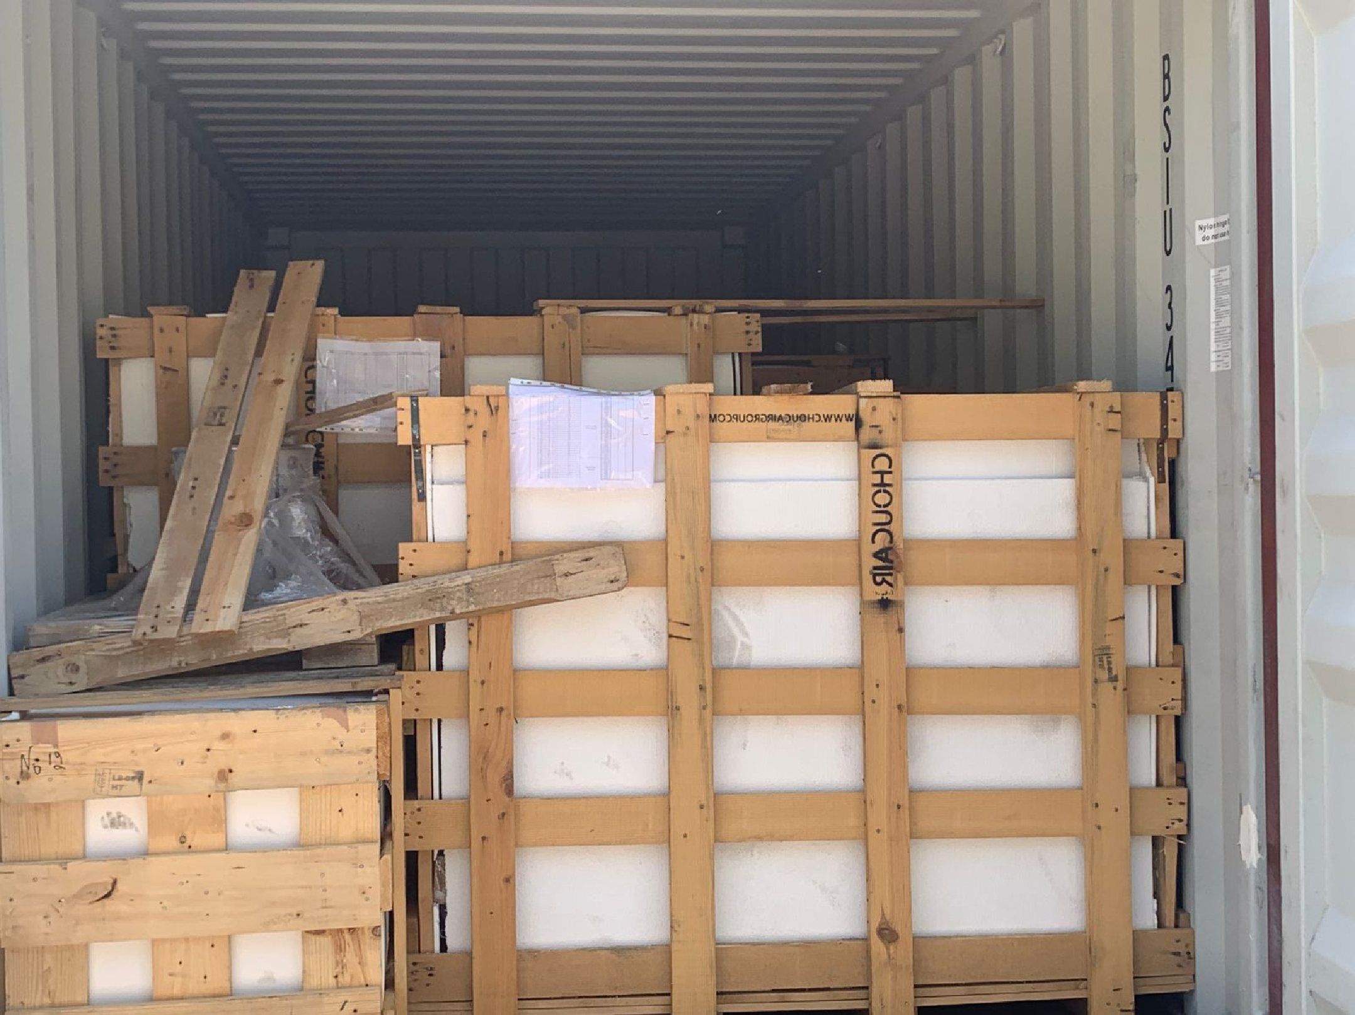 | 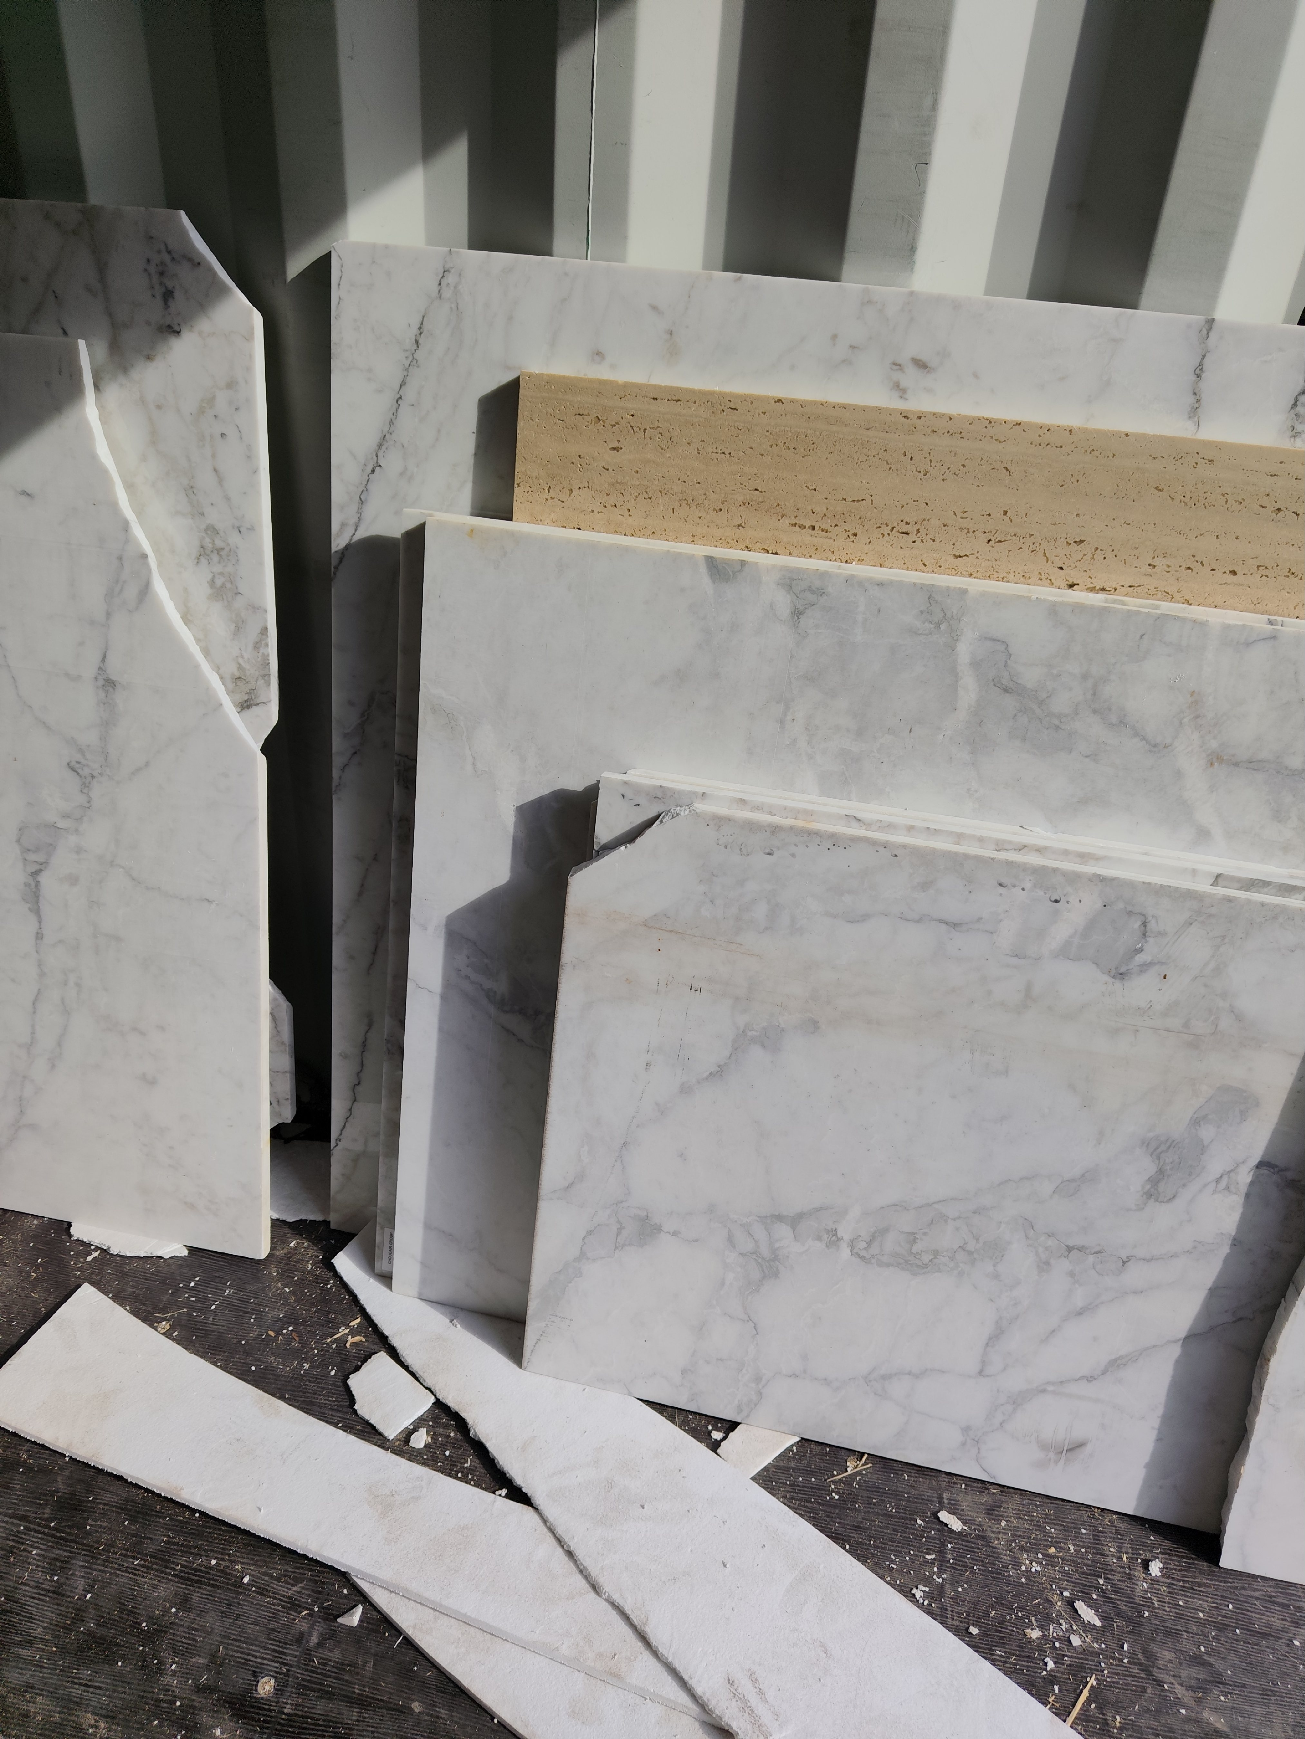
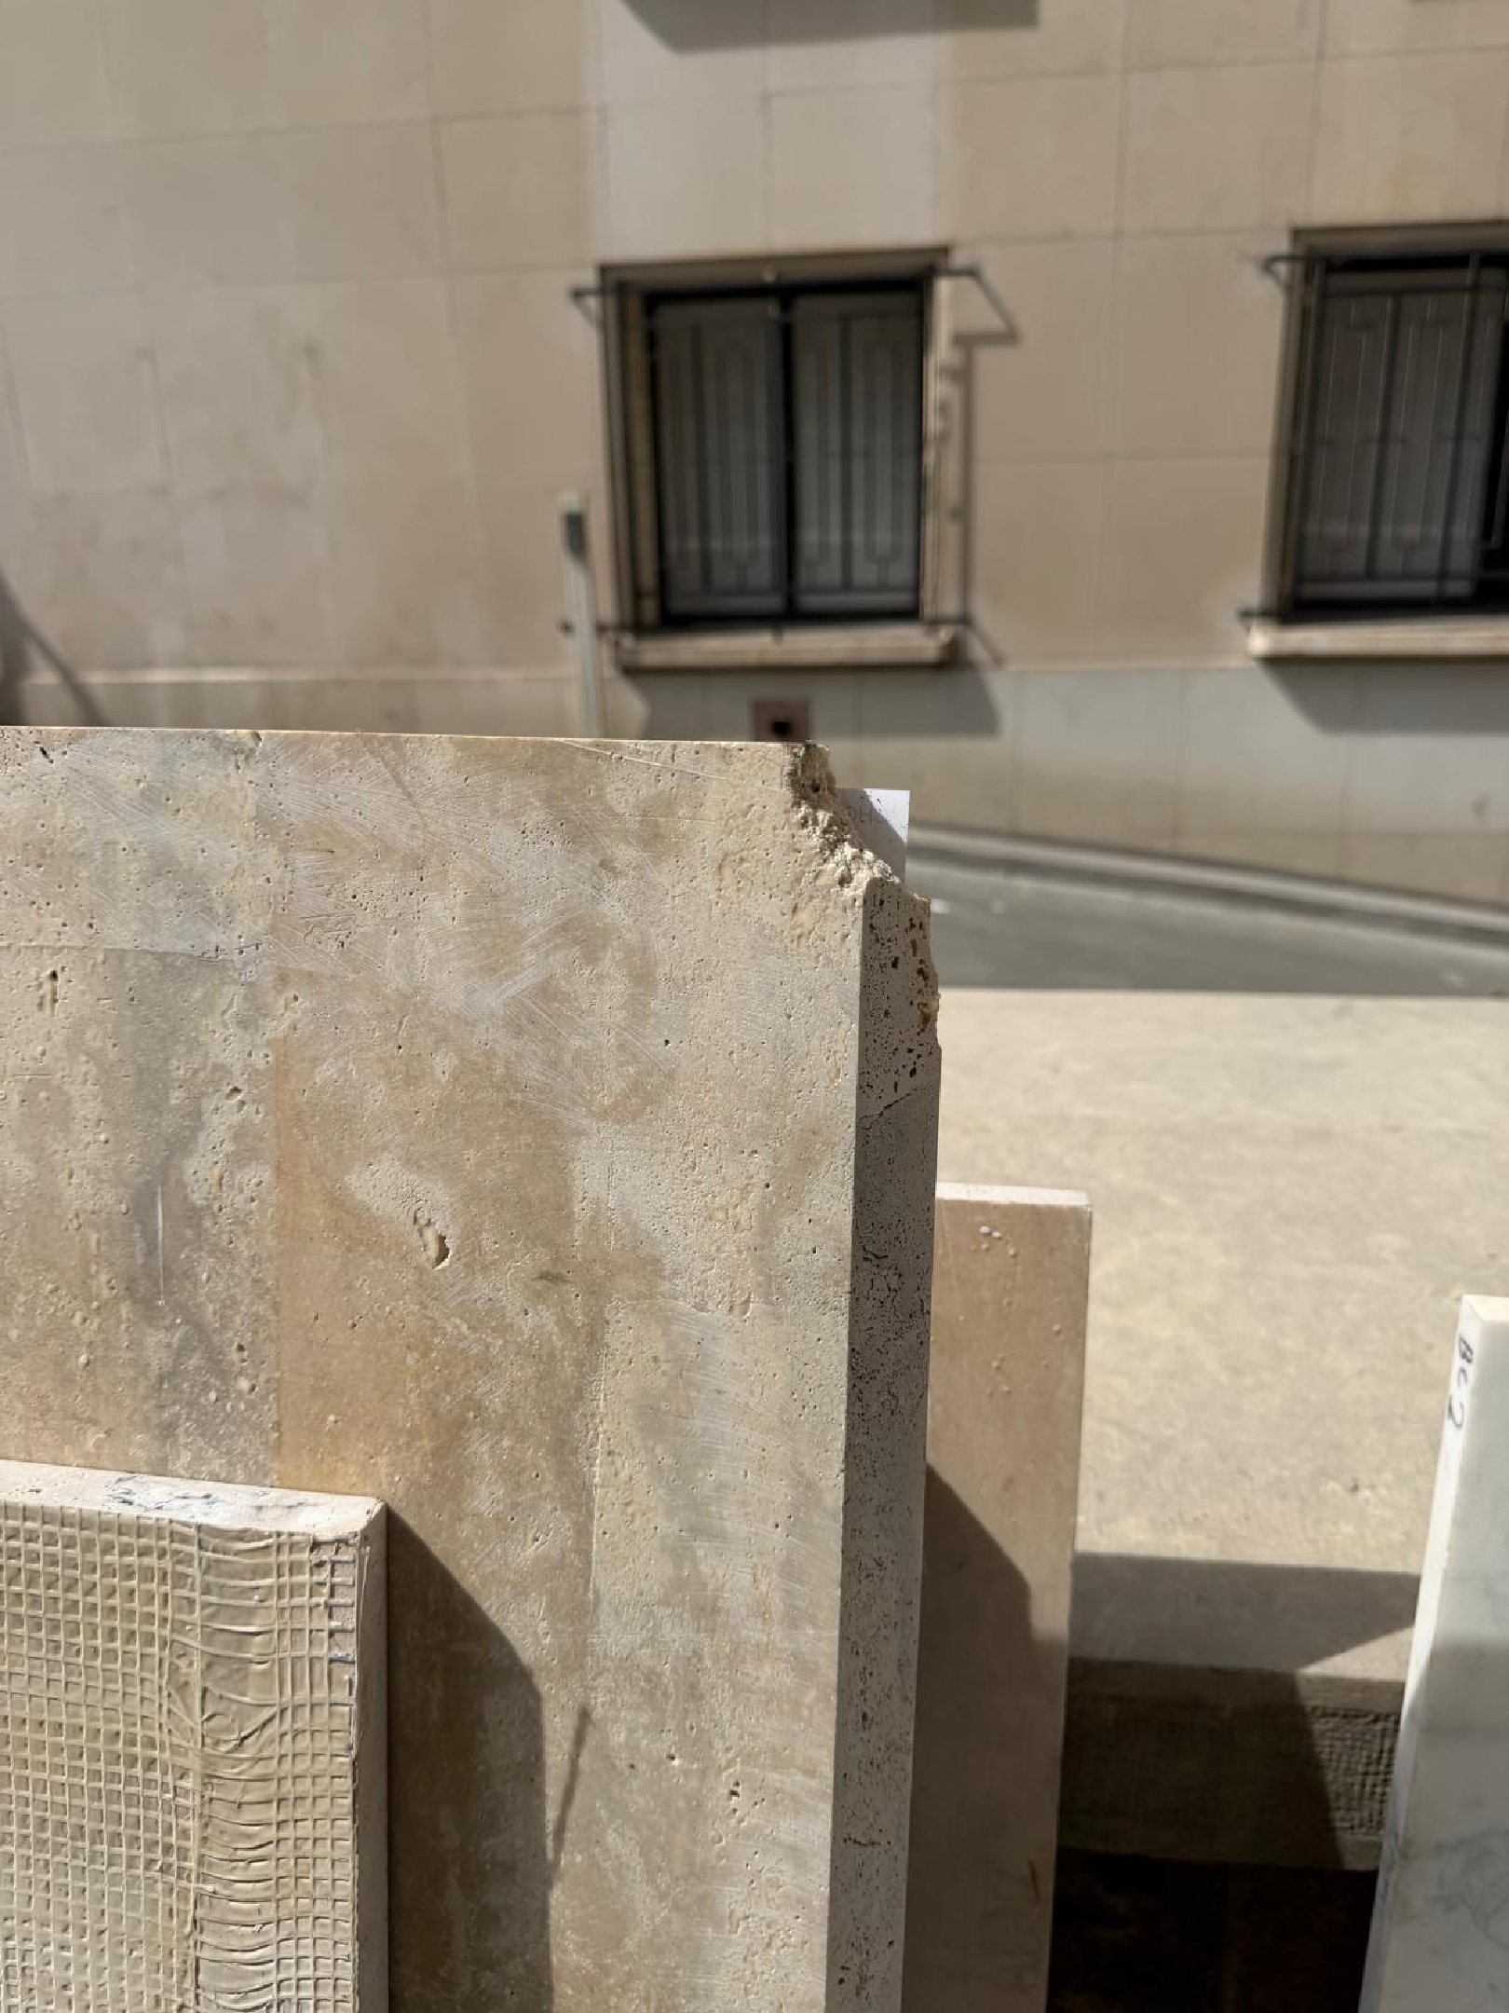 | 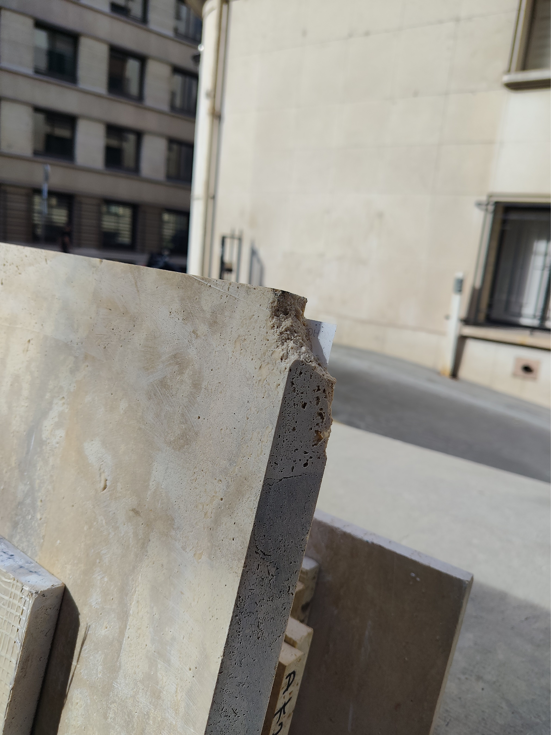

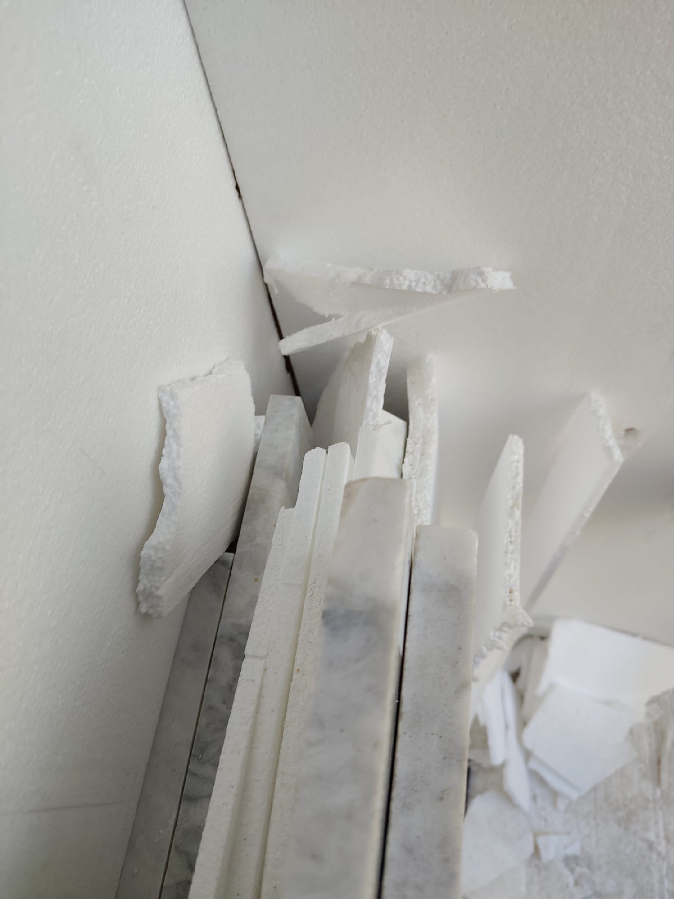 | 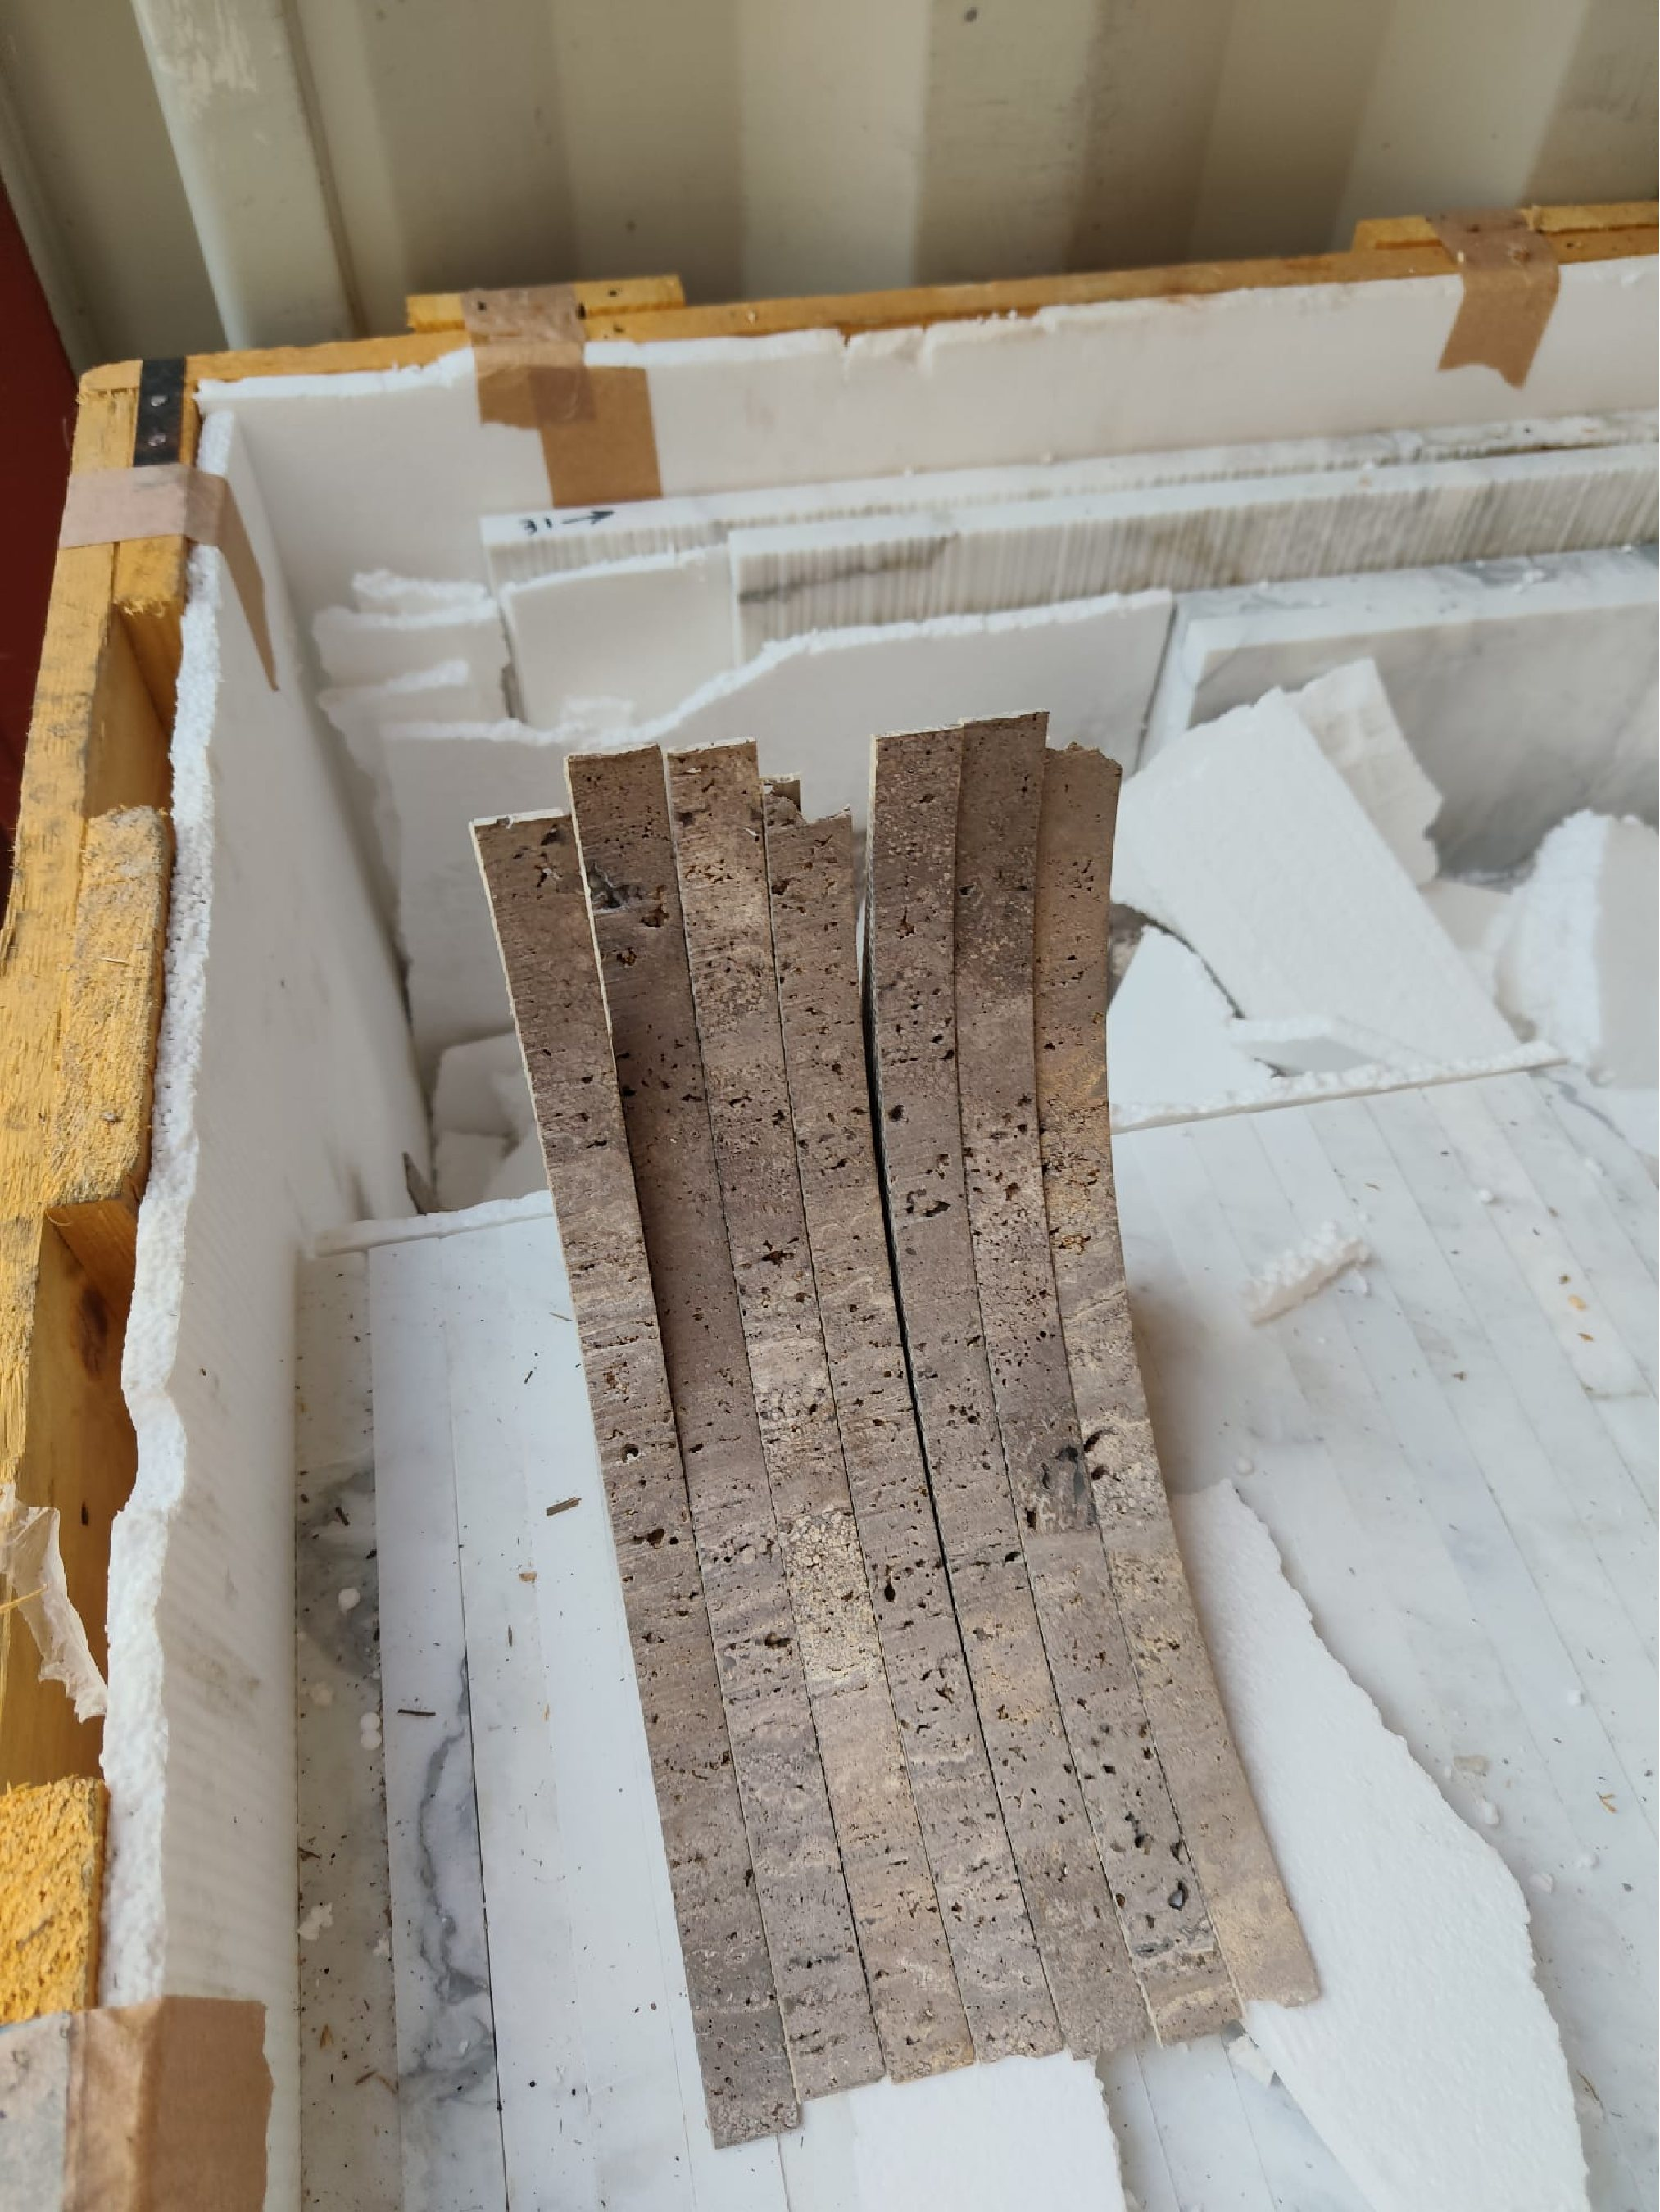
About ULA
United Loss Adjusters and Surveyors (ULA) is a leading international provider of Adjusters, Surveyors, Solicitors and Consultants, offering unrivalled technical and legal solutions with exclusive access to the London Market's leading specialists.
Founded in 2002, with strategic head offices in the Middle East and the United Kingdom, today ULA is the strategic ally of a world-leading legal firm (with offices in over 60 major countries) and the correspondent for a number of global technical service providers (with offices in 140+ countries), with principals including but not limited to Insurers, Reinsurers, Brokers, P&I clubs, Ship Owners, Shipyards and Agencies.
Lines of business:
- Insurance & Re-insurance
- Claims solutions and loss adjusting across all major lines: aviation, cargo, marine, property, fine arts and special risks claims
- Cargo & Containers
- Marine & Offshore
- Global Claim Recoveries & Legal Support
Our team:
Our team of qualified professionals experienced in the fields of Marine, Insurance, Finance, Engineering and Law known and respected for their integrity and credibility. Supported by a highly mobile team strategically positioned where our services are needed, we are always available on short notice to deal promptly with your queries. ULA is independent to the core and can be trusted to express unbiased views, and is not influenced by stakeholders.
ULA’s team members are recognised:
- Chartered Engineers
- Consultants
- Inspectors & Auditors
- Insurance & Re-Insurance Underwriters
- Loss & Average Adjusters
- Master Mariners & Chief Engineers
- Naval Architects, Marine & Offshore Engineers
- Solicitors
- Sworn Surveyors
ULA’s team members are also recognised members of the following international institutions:
- The Association of Average Adjusters (AAA)
- The Bar Council of England and Wales
- The Chartered Insurance Institute (CII)
- The Chartered Institute of Loss Adjusters (CILA)
- The European Federation of Loss Adjusting Experts (FUEDI)
- The Institute of Fire Engineers (IFE)
- The Institute of Marine Engineering, Science and Technology (IMarEST)
- The UK Engineering Council
- The Royal Institute of Naval Architects (RINA)
- The International Institute of Marine Surveying (IIMS)
- The Royal Institute of Chartered Surveyors (RICS)

Contact person
United Kingdom: 71-75 Shelton Street, Covent Garden | London, England - WC2H 9JQ
Middle East: Mina Tower, Ain Warda Street | Beirut, Lebanon - WG2G+5CX

Registered name United Loss Adjusters and Surveyors Ltd.

24/7 Contacts & Claim Support – T: +44 (0) 20 3287 3326 | M/WhatsApp: +44 (0) 7 375 110 573
Office E: mailto:claims@unitedlossadjusters.com
W: https://www.unitedlossadjusters.com/



